***Madhwa Connect***[***Core Team***](http://madhwaconnect.com/core-team/)***Members***

1. **Hanumant Sulibhavi**

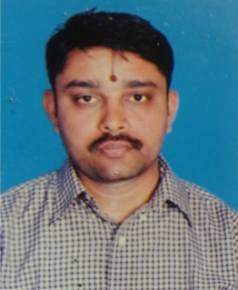

1. Aravind. S

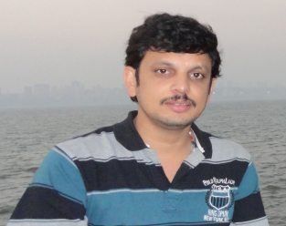

1. Vadiraj Sulibhavi
2. Ananth Prasad S

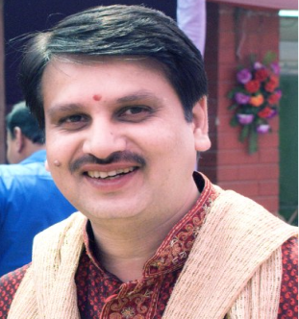

***Under Guidance of***

**Dr. Vinayakachar Namannavar. Sanskrit professor, MA,PHD**

